**LAB 1**

**Title:** Introduction to DDL and DML statements in SQL.

**Objective:**

• To be familiar with concept of DDL and DML.

• To use different DDL and DML statements to perform various operations on database.

* **Practice Question List With Solution:**
* **Create database eemc\_db.**

**C:\Users\Sax_yam\dar.png**

* **Create table Student\_info with following column and datatype.**

|  |  |  |  |  |
| --- | --- | --- | --- | --- |
| SID | NAME | CONTACT | FACULTY | COLLEGE\_NAME |
| int | Varchar(30) | Varchar(30) | Varchar(30) | Varchar(30) |

****

* **Now add column named address with datatype varchar(30).**

**C:\Users\Sax_yam\q2.png**

* **Delete column named contact.**

**C:\Users\Sax_yam\q3.png**

* **Rename column name address as location.**

**C:\Users\Sax_yam\ren.png**

* **Change datatype of faculty to char(20).**

**C:\Users\Sax_yam\q6.png**

* **Insert minimum 10 information of student into table named student\_info.**

**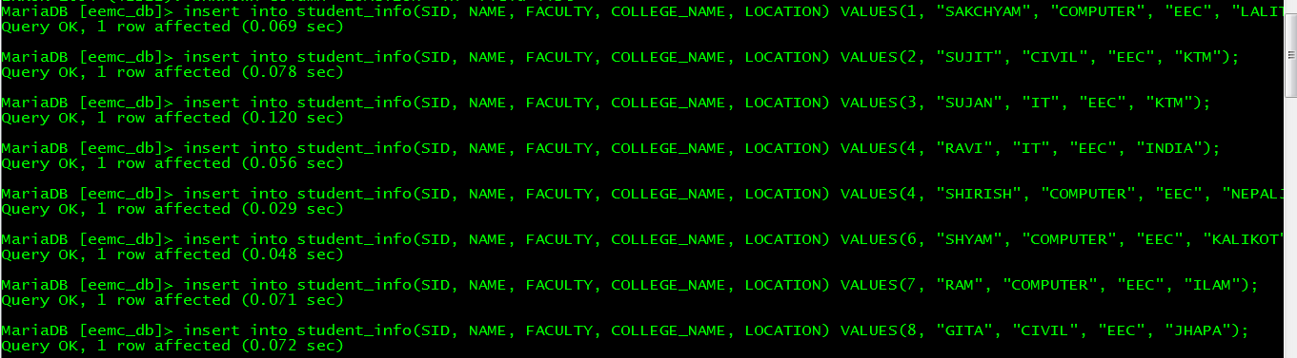**

* **Insert 1 information of student whose faculty is not known.**

**C:\Users\Sax_yam\Q8.png**

* **Insert 2 information of student whose college\_name is not known.**

****

**Output:**

**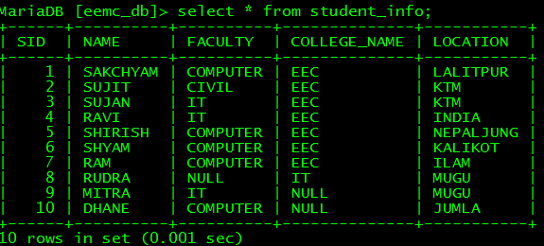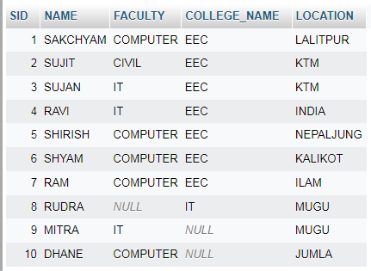**

* **Update the information of student whose sid=3 by setting faculty =’civil’.**

**C:\Users\Sax_yam\Q10.png**

* **Update the information of student whose name is ‘RAVI’ and location is ‘INDIA’ by setting faculty=’computer’.**

**C:\Users\Sax_yam\Q11.png**

* **Delete the information of student whose faculty is IT and location is MUGU.**

**C:\Users\Sax_yam\q12.png**

* **Display all the information of student from table named student\_info.**

**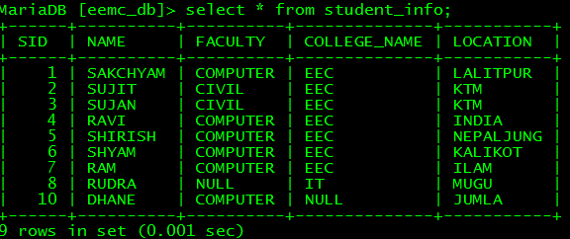**

**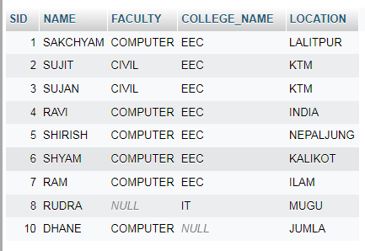**

* **Display name and faculty of student whose location is lalitpur and college\_name is EEC.**

**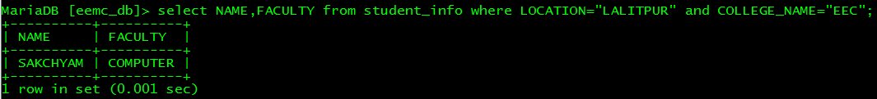**

* **Delete all rows from table.**

**C:\Users\Sax_yam\q16.png**

* **Delete the table named student\_info.**

**C:\Users\Sax_yam\q17.png**

* **Delete the database named eemc\_db.**

**C:\Users\Sax_yam\q18.png**

* **Discussion:**

Here, we use xampp control panel to perform our first lab in Database Management System. XAMPP is used to serve the web pages on the Internet. It can also use to create and manipulate databases in Maria DB and SQLite, among other databases. Once XAMPP is installed, an FTP client can connect to a local host and treat it as if it were a remote host.  Before you can use your development environment, Apache and MySQL must be running. The main advantage of it is a free and open-source cross-platform web server solution stack package for all types of operating systems like Linux and Windows.

* **Conclusion:**

Hence, after completing Lab1, we get familiar with the concept of DDL and DML. Moreover, we learn how to use different DDL and DML statements to perform various operations on database management system.

**\*\*\*\*\*\*\*Thank You\*\*\*\*\*\*\***